| KSU_logo.jpg | **King Saud University**  **College of Computer and Information Sciences**  **Department of Computer Science** |
| --- | --- |

**CSC 220: Computer Organization**

**Labwork - #5**

Name: saud alkahtani, id: 436102946,day=Sunday,Hour:4to6

1. **Introduction**

Design complex logic circuits

1. **Experiments**

**In the next paper!**

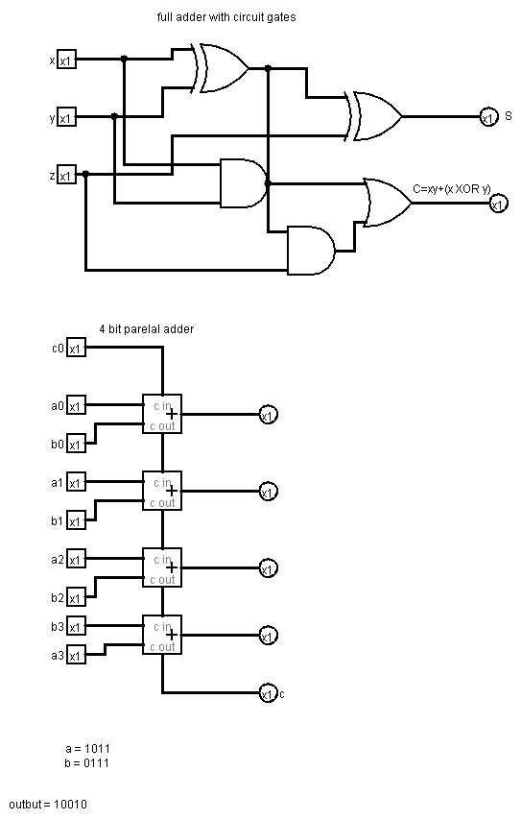b

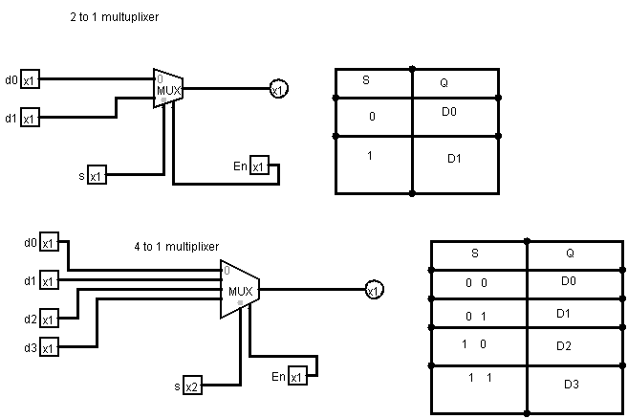

1. **Results**

**Full adder truth table**

| **X** | **Y** | **Z** | **C** | **S** |
| --- | --- | --- | --- | --- |
| **0** | **0** | **0** | **0** | **0** |
| **0** | **0** | **1** | **0** | **1** |
| **0** | **1** | **0** | **0** | **1** |
| **0** | **1** | **1** | **1** | **0** |
| **1** | **0** | **0** | **0** | **1** |
| **1** | **0** | **1** | **1** | **0** |
| **1** | **1** | **0** | **1** | **0** |
| **1** | **1** | **1** | **1** | **1** |

**Truth table for 2 to 1 multiplixer**

| **S** | **Q** |
| --- | --- |
| **0** | **D0** |
| **1** | **D1** |

**Truth table for 4 to 1 multiplixer**

| **S** | **Q** |
| --- | --- |
| **0 0** | **D0** |
| **01** | **D1** |
| **10** | **D2** |
| **11** | **D3** |

1. **Discussion**

We can design multiplixer and full adders either with normal logic gates or with pre made adders and multiplixers